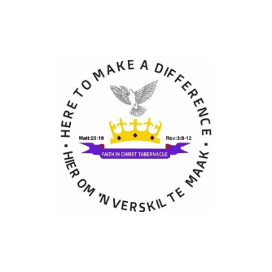
SUPPORT OUR CHURCH

Doing church ministry is not easy. At least, it is not easy to do church ministry well. Just about any church can throw open the doors on Sunday, master up enough volunteers, scramble to get enough money in the collection plate, and survive. The problem is, our Lord does not want His church to simply survive, He wants His church to thrive. To make sure that the hurt and oppressed get the necessary help is our mission. We do offer counselling to victims of abuse and support the depressed and provide assistance to impoverished families by supplying food rations, clothing and support to the homeless, poor, orphans and elderly people of our community.

Our funding Model

Presently funds are sourced from:
- Tithes and offerings from Church Members
- Functions organized by the Church
- Donations
- Potential Sponsors
- Church Partners
Current assistance needed
- Proper worship centre to better service our community (Building Project)
- Food ratios
- Clothing
- Musical equipment and Instruments

You are welcome to partner with us and make the difference needed in our communities and in the lives of all reachable. Your wholehearted support can change the lives of many in need of physical, emotional and spiritual assistance. A copy of our NPO Certificate is available on request. Banking details are as follows:
Bank: FNB Bank
Account Holder: Faith In Christ Tabernacle
Account Type: Business Cheque Account
Branch: Brits
Branch Code: 260 145

NPO Registration
Registered with: Social Development Brits
Registration No.: 129-177 NPO

Wholehearted contributions and support can be made directly into the Church bank account. Donations such as food rations, clothing and any other items can be drop off at the church, contacting Pastor ED Jocims at 084 485 3179 or Minister GZ Jansen at 083 561 2371 for arrangements. Your can also pray and joint us in partnership by contributing a monthly financial seed. Please feel free to contact us for any further information required. Shalom

